VERSION HISTORY
VER. | VERSION DETAIL/S | AUTHORED BY: | APPROVED BY: | DATE APPROVED
1.0 | Agreed and SIGNED OFF Guidelines | Indra | Globe ISG | 12/20/2019

DOCUMENT UPDATE HANDLING

The RPA CoE Core team will have a quarterly cadence in order to evolve the documents and to improve the guidelines based on the experiences from previous quarter. The document will have the same people assigned to review and sign-off. In case there are changes in the approvers, the new person assigned to review and update the document must be listed in the version control table of the document

Table of Contents
1. INTRODUCTION 3
1.1. Purpose of this document 3
1.2. Audience 4
1.3. Glossary 4
2. PURPOSE AND OBJECTIVES OF THE SERVICE 5
3. SUPPORT & OPERATION FUNCTIONS AND PROCESSES 7
3.1. SUPPORT 8
3.1.1. Opening Hours 8
3.1.2. Service Desk function (L1) 8
3.1.3. Event Management process 9
3.1.4. Incident Management process 16
3.1.5. Problem Management process 18
3.2. OPERATIONS 18
3.2.1. Opening Hours 18
3.2.2. Request Fulfilment process 18
3.2.3. Operations Tasks 19
3.3. Roles & Job Descriptions 21
3.3.1. RPA Service Delivery Manager (SDM) 21
3.3.2. Support Analyst 22
3.4. Service Level Agreement (SLAs) Management process 22
3.4.1. How to define Impact? 22
3.4.2. How to define Urgency? 23
3.4.3. How to determine the Criticality? 23
3.4.4. L2 ISG RPA Support service 24
3.5. L2 Support Service reporting 25
4. Continuous Improvement 26
APPENDIX 27
I. Preconditions on Running the Robot/s 27
a. Package - ensuring that there is a package uploaded 27
b. Robot – ensuring that the robot is available / busy 28
c. Schedule – ensuring that the preferred schedule running time of the Robot is configured in the Orchestrator 28
d. Assets – ensuring that credentials, URLs, links are updated in the Orchestrator 29
II. Manually Running the Robots 30
REFERENCES 31

INTRODUCTION

Purpose of this document

The main goal of this document is to present the process model guidelines applicable to the RPA Application Level 2 Support & Operations service, necessary to fulfil the Business expectations.

Chapter 3.1.2 Service Desk function (L1). Describes how this function relates to the L2 RPA Support service

Chapter 3.1.3 Event Management process. Describes the features of the Monitoring tool associated to the UiPath RPA solution; which provides additional event management capacity & capabilities on top the standard Globe’s ones based on Splunk.

Chapter 3.1.4 Incident Management process. Do not goes into the details of the process, since this service fully adheres to what it is documented in the “Globe - L1 Service Desk SoW”.

An emphasis is put in the importance of the Configuration Item (CI) set-up in order to manage them properly to understand which is the involved automated process and therefore which is the right Resolver group to which an Incident may be escalated, since there may be many different Resolver groups in charge of different automated processes

Chapter 3.1.5 Problem Management process. Do not goes into the details of the process, since this service fully adheres to what it is documented in the “Globe - L1 Service Desk SoW”.

Chapter 3.2.2 Request Fulfilment process. Do not goes into the details of the process, since this service fully adheres to what it is documented in the “Globe - L1 Service Desk SoW”.

The emphasis is put in the importance of the Service Request Catalogue set-up in order to manage all pre-authorized Service Request the Business can forward to the Service Desk.

Chapter 3.3 Service Level Agreement (SLAs) Management process. Defines how impact and Urgency are calculated, and the respective SLA for each of the levels.

Chapter 3.4 L2 Support Service reporting.

This document also describes what it is necessary to implement in the Services described in the two previous documents, in order to provide the Governance for this new IT domain.

Audience
This document is directed to the following roles:
- Mandatory:
  - Managers and members of the Service Desk function
  - RPA Service Delivery Manager / DevOps Coach
  - DevOps Engineer
  - RPA Support Ops & Support Team
  - Platform SDM (s)
- Recommended:
(done)

Glossary

AWS | Amazon Web Services
CAB | Change Advisory Board
CI | Configuration Item
CMS | Configuration Management System
DBA | Database Administrator
ECAB | Emergency Change Advisory Board
ISG | Information Systems Group (a Globe’s division)
ITIL | Information Technology Infrastructure Library
ITSM | IT Service Management
KT | Knowledge Transfer
RDS | Relational Database Service, provided by Amazon
RPA | Robot Process Automation
SDM | Service Delivery Manager
SKMS | Service Knowledge Management System
SoW | Statement (or Scope) of Work

PURPOSE AND OBJECTIVES OF THE SERVICE
The purpose of the RPA Application Level 2 Support & Operations service is to coordinate and carry out the processes and activities required to deliver and manage Production Services at the agreed levels to the Business users. All configurations from Deployment to Operation and Support on each automated process must be done according to the particular characteristics of each process, as described in the Operation and Delivery Handbook (ODH) of each process. This document is produced during the development phase of a process, and is part of the handover of a process to production. This document should be a living document, and evolve in conjunction with the CI created for each process.

This service, in principle, adheres to the L1 & L2 support governance already defined by Globe whose details are described in the following two documents:
- Globe - L1 Service Desk SoW - v19_Globe.doc
- Globe - L2 Application Support SoW - v17_Globe.doc

The Service structure is based on three (3) levels in order to avoid waste and to be as Lean as possible:
- Level 1: The Service Desk and the Command Center functions; both corporate services provided by ISG.
- Level 2: The RPA application support and operation service, provided by an ISG partner / third party and the providers chosen by specific BUs. In the future, following DevOps practices.
- Level 3: All software vendors engaged in the RPA iniciative, i.e. UiPath, ElasticStack, Splunk, etc.
The following diagram shows the proposed structure for this service, which is based on three levels:

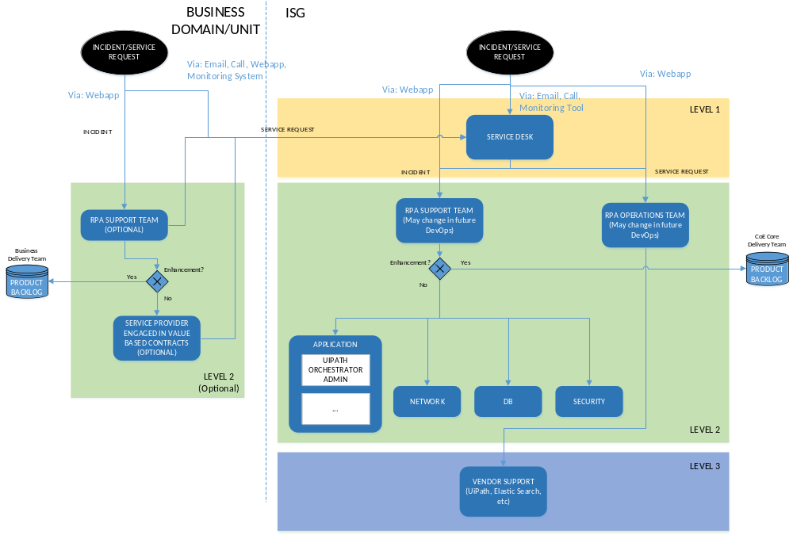
Figure 1. Support and Operations Organigram

SUPPORT & OPERATION FUNCTIONS AND PROCESSES
The ITSM tool (Remedy) should be configured for the RPA Tickets. There are two configuration for the ITSM tool:
- Configure the Service Catalogue, refer to 3.2.3 Operations Tasks
- Create a workflow of the ticket states
There should be an option for “Incident” or “Service Request” for the L1 Service Desk to choose from whenever there are issues in RPA. Incidents are processed by the RPA Support Team, whereas, Service Requests are processed by the RPA Operations Team.
There are different designation of Incident tickets:
- Assigned for tickets to be assigned to respective support person.
- In Progress for tickets currently being resolved by the respective support person.
- Resolved for tickets that has been resolved.
- Pending are tickets that needs another process to proceed. Some other reasons for pending are:
  - End User Pending
  - Supplier Repair
  - User Availability
  - Waiting for Approval
  - Waiting for Parts
  - Waiting for Problem Resolution
  - Waiting for Request Completion
  - Waiting for Third Party Support
  - AMDOCS Pending
- Re-opened for tickets that are resolved but the user is not satisfied with the resolution.
There are different designation of Service Request tickets:
- Pending waiting for approval from SDM (the ones it applies), refer to 3.2.3 Operations Tasks.
- Assigned for tickets to be assigned to respective operations person.
- In Progress for tickets currently being resolved by the respective operations person.
- Resolved for tickets that has been resolved.
- Pending are tickets that needs another process to proceed. Some other reasons for pending are:
  - End User Pending
  - Supplier Repair
  - User Availability
  - Waiting for Approval
  - Waiting for Parts
  - Waiting for Problem Resolution
  - Waiting for Request Completion
  - Waiting for Third Party Support
  - AMDOCS Pending
- Re-opened for tickets that are resolved but the user is not satisfied with the resolution.
The RPA L2 Service comprises two areas:
- The Support side; which is highly related to the Service Desk and the Command Center functions and the Event, Incident and Problem Management processes
- The Operations side; which is more related to the Request Fulfilment process and the Operation side of the service itself.

SUPPORT

Opening Hours

Due the not planned nature of the processes & activities resulting from incidents, this side of the service is candidate to be a 7*24 service.

Service Desk function (L1)

The Service Desk (L1) is a central function provided by the Globe’s ISG organization where all Business and IT users can report Incidents and request services. Incidents are recorded using the Remedy ITSM tool and all Globe’s employees and some authorized third parties have access to it. A web platform is also available for self-ticket creation, it can be found at https://myglobeitservices.my.salesforce.com/

The web platform and the Service Desk (L1) are the single points of contact to raise Incidents. Service Desk preferred channel is telephone, at 0 277 301 911 or 0 917 588 8303. In case of unavailability, issues can also be raised via email to gtisgservicedesk@globe.com.ph / gtisgsdsup@globe.com.ph.
For the RPA domain it is expected the Service Desk to work initially with a “pick & dispatch” approach based on CI data. Later on, it will be assessed if there exists a technical/human resources availability to perform more than the initial triage of Incidents and to attempt to resolve.

The Command Center can raise Incidents based on the events they detect over the infrastructure, network, security and the applications layers. The main tool used by them to monitor the environment is Splunk. For details on the tool, see www.splunk.com/en_us/it-operations.html.

It is fundamental that every time a new Service is introduced into Production, the CI data within the CMS to be updated accurately. This information item is the one that will be used by the Service Desk (L1) and by the Command Center to determine how to escalate a ticket to the right L2 Support team, the one within ISG or the others hanging directly from some Business Units (BUs).

Event Management process

An event can be defined as any change of state that has significance for the management of a Configuration Item (CI) or an IT service. Events are typically recognized through notifications created by an IT Service, a CI or a monitoring tool.

This L2 Support service will use the monitoring capacities of the UiPath Orchestrator monitoring tool and indirectly, the ones used by the Command Center.
      - Orchestrator monitoring

UiPath Orchestrator is a centralized robot management dashboard available as a web application.

Orchestrator’s main functionalities are:
- Provisioning - creates and maintains the connection between Robots and web application,
- Deployment - assures the correct delivery of the package versions to the assigned Robots for execution,
- Configuration - maintains and delivers Robot environments and processes configuration,
- Queues - ensures the queues and queue items management,
- Monitoring - keeps track of Robot identification data and maintains user permissions,
- Logging - stores and indexes the logs to an SQL database and/or ElasticSearch (depending on your architecture and configuration),
- Inter-connectivity - acts as the centralized point of communication for some third party solutions or applications, i.e. Elastic Search.
This document will focus in the Monitoring of the robots using the UiPath Orchestrator environment/tool.

The Orchestrator monitoring should be performed by the L2 Support groups, both within ISG and within the BUs.

Every robot can be monitored from the Orchestrator dashboard according to what is defined in the process specific Operations and Deployment Handbook (ODH).
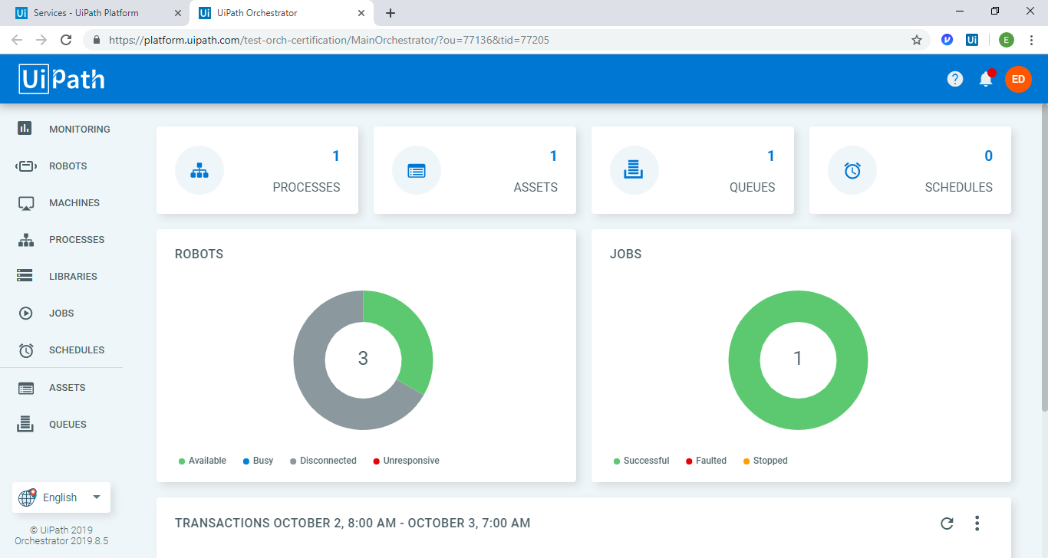

From the dashboard, the Support Analysts can see the number of robots connected to the Orchestrator, the number of processes or packages deployed, the number of Assets (Bool, Integer and Credentials) used by the Robots, the Queues created for the Robots, and the Schedule created for each unattended robots. Attended Robots do not have a schedule; rather, they are triggered manually.

Monitoring of Robots

Below are the steps on running, monitoring and troubleshooting the robot.

Heartbeat of the Robot/s

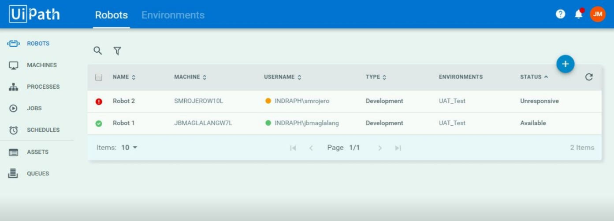

The possible statuses of the Robots are listed below:
- Available - the Robot is not running a process and is free to be used; or waiting for the scheduled activity.
- Busy - the Robot is running a process;
Note: When the status of the robot is Busy, do not access/interrupt the desktop / remote desktop (for virtual machines) as it may stop the current session of the Robot.
- Unresponsive - the Robot and Orchestrator have not communicated in the last two minutes - the default scenario. This value can be configured in the web.config file.
- Disconnected - the UiPath Robot service is not running.
Troubleshooting

Robot’s stop running

When the robot/s stopped running, there are two reasons as to why it happened:
- Robot/s stopped running the job; or
- Robot/s became Unresponsive or Disconnected

Robot/s stop running the job

Check the status of the robot/s: Go to Robots on the left sidebar.

In this scenario, the Robot/s should still be Available. The robot/s just stopped running the job as it experienced an unhandled exception.

Resolution: For unattended robot/s, It is necessary to wait for the Orchestrator to run the next job. The predefined schedule will trigger the next job. It is recommended to monitor the next run of the Robot by accessing the remote desktop through a different server. Double check if all the Preconditions on Running the Robot/s are correctly defined.

Robot/s became unresponsive or disconnected

Check the status of the robot/s: Go to Robots on the left sidebar.
In this scenario, the Robot/s should be Unresponsive or Disconnected. This happens when the connectivity between the robot and the Orchestrator was lost, or the UiPath Robot service itself has stopped.

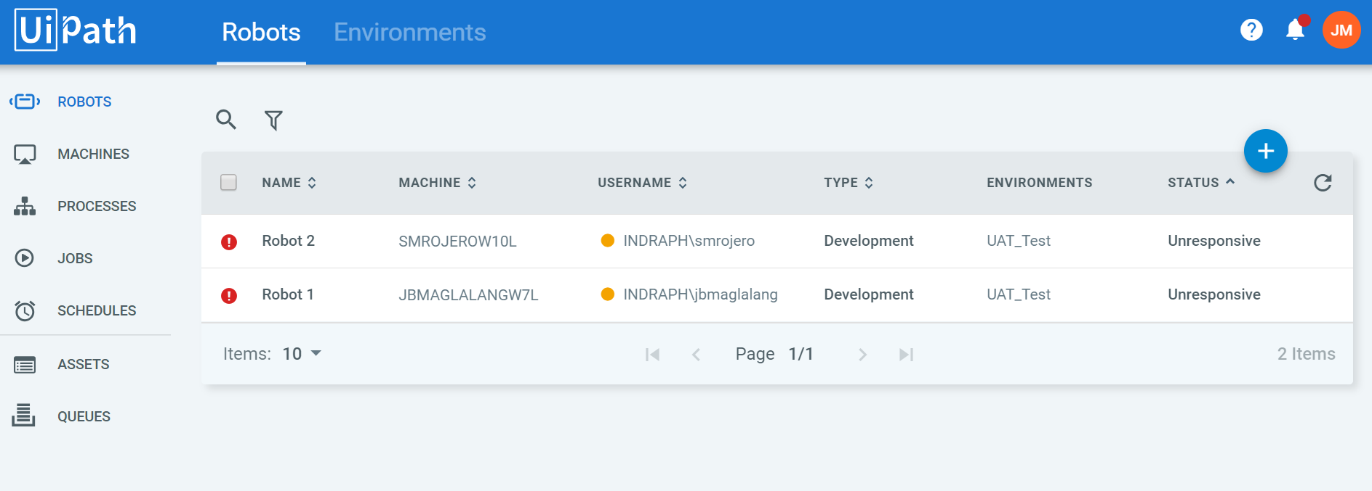
Resolution:
- In the right side of the Windows taskbar, check if the UiPath Robot is still running in the virtual machine.

- Check the status of the UiPath Agent in the taskbar. Should be Error connecting to Robot Service.
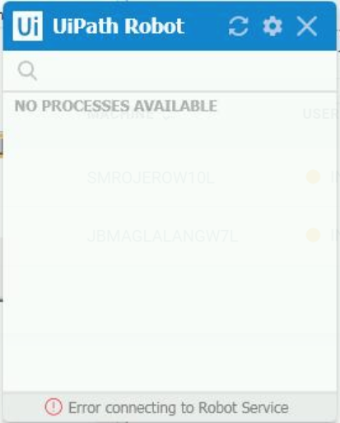
- Go to Windows Services by pressing “Windows” + R” and type services.msc.
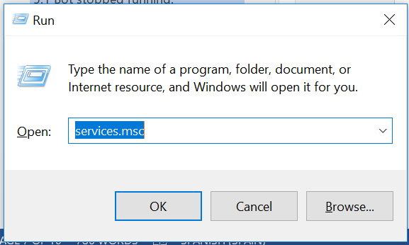
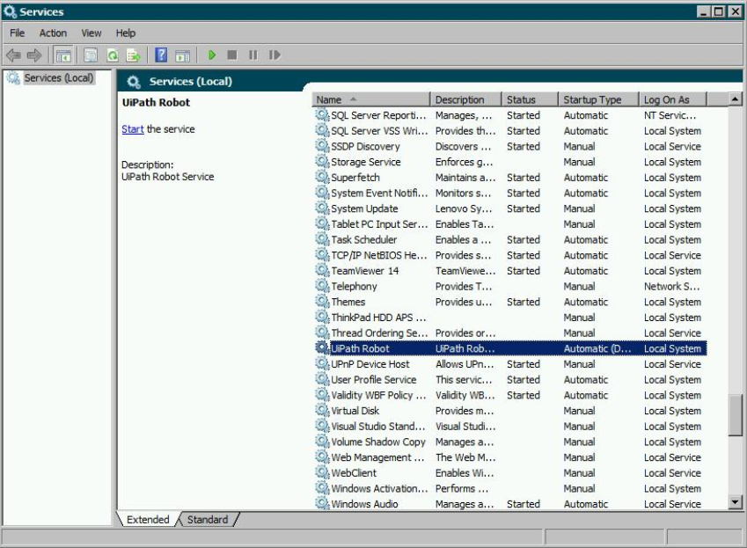
- In the Windows Services, select the UiPath Robot service. Once selected, on the left side, click Start the service.
- Wait until the UiPath Agent change the status to Connected, licensed.
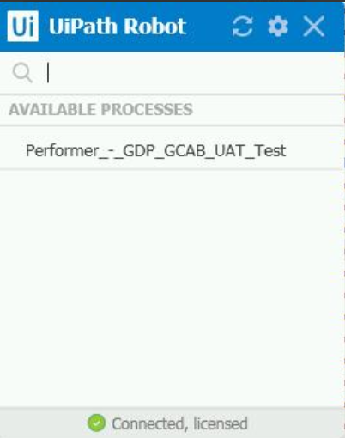
- The robot/s should now become Available. For unattended robot/s, we just have to wait for the Orchestrator to run the job. The predefined Schedule will trigger the next job.

Unhandled Exceptions

Unhandled exceptions are exceptions not mapped in the process map. These are unexpected exceptions that is experienced by the robot. For these kinds of exceptions:
- First, you need to access the Orchestrator through a different server (for example your Robot is running in 10.237.181.164 , you need to access another server).
- Second, open the Orchestrator then go to Schedules, stop or disable the scheduling of your bot.

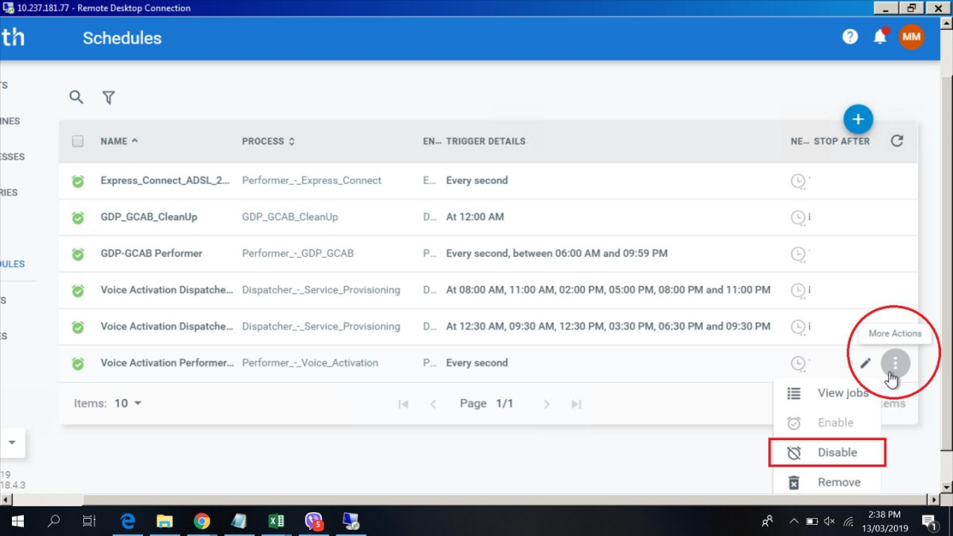

- After stopping the Schedule, set all Pre-conditions needed before running the Robot.
- Lastly, go to orchestrator > Schedules > Enable the Schedule.

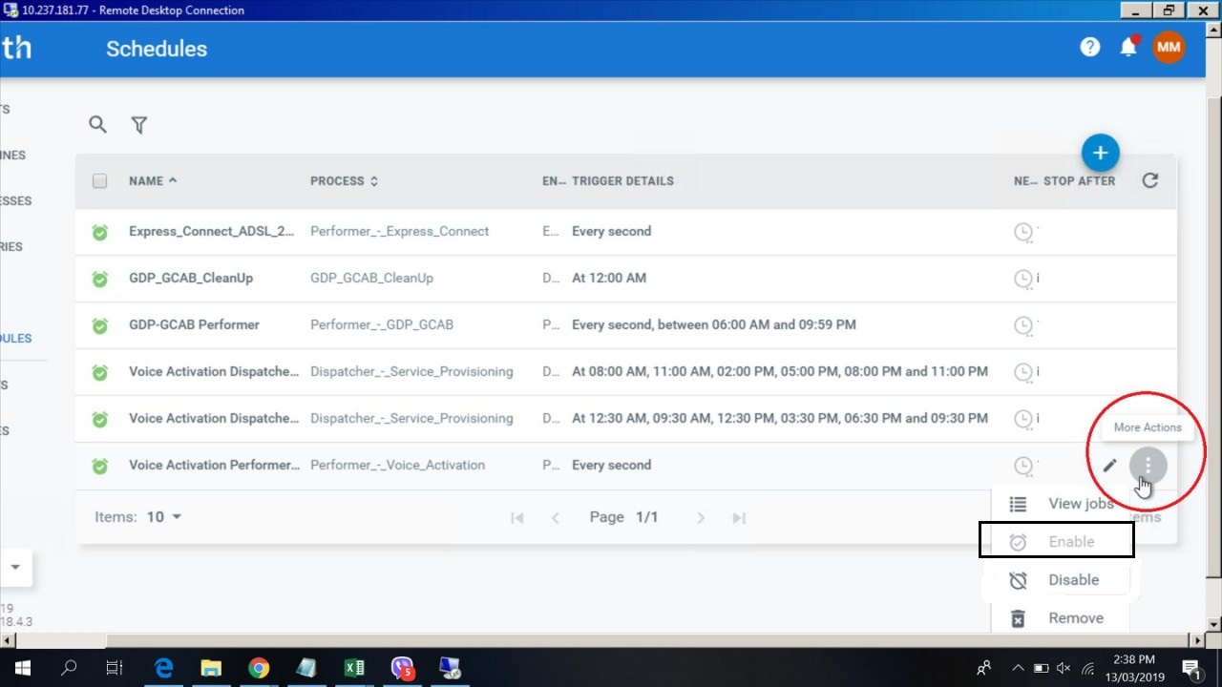

      - Infrastructure monitoring

The Infrastructure monitoring is performed by a function within ISG named Command Center.

Their main monitoring tool is the Splunk App for Infrastructure (SAI); which needs the installation of an Agent (the Universal forwarder) on each ISG Windows server part of the RPA Architecture.

These Agents reads the logs and forward the data to Indexers, where the information is stored and can be viewed through Search Heads, which is the web tools available for end users. The Command Centre uses this source to identify and analyse potential Incidents. If is the case, they will raise an Incident manually within Remedy and escalated them to the appropriate Resolver group based on the CI related data.

The UiPath’s Orchestrator is highly dependent on the availability of the UiPath Database; so some specific infrastructure monitoring is essential in order to detect trends in the Database (AWS RDS) used by the Orchestrator that may cause loss of this service.

AWS RDS provides and interface to set-up events (event subscription); which can be forwarded by email to the Command Center and/or to Globe’s DBAs.

The Database monitoring is one of the most important tasks Globe’s DBAs must perform to ensure availability and performance of the RPA related services.

Some details about how the monitoring of the AWS RDS SQL Server instances set-up, can be reviewed on https://www.sqlshack.com/aws-rds-sql-server-monitoring-database-instances/.

Is highly recommended to implement some AWA RDS Database monitoring as well as the monitoring of the trends in the utilisation of bandwidth between Globe’s data centers and the Amazon cloud.

Incident Management process

Incident Management is the process responsible for managing the lifecycle of all Incidents may be recognized by technical staff, detected and reported by the Command Center, communications from users (usually via a telephone call to the Service Desk – L1), or reported by third party suppliers or partners.

The main purpose of the Incident Management process is to restore the normal service operation as quickly as possible and to minimize its adverse impact on the Business Operations, thus ensuring that agreed levels of service quality are maintained.

“Normal Service Operation” is defined as an operational state where services and CIs are performing within their agreed service and operational levels.

The RPA IT domain will adhere to the best practices considered in the “Globe - L1 Service Desk SoW - v19_Globe” documentation.

In order to assist in the escalation of an Incident from the “Service Desk – L1” to the right RPA L2 Resolver Group, there is a key element that needs to be recorded within the Remedy ticket, the CI data.

Every project responsible for introducing a new Service into Production, should update the CMS with all relevant new associated Cis using the ODH of the process. This list should at least include the delivery of the project itself, i.e., Internal CIs such of automated processes, the target applications and licenses, Interface CIs, documentation, within others.

The CI data is relevant for Incident escalation and for Impact Assessment purposes.

Since the Service Desk (L1) will work with a “catch & dispatch” approach, the L2 Resolver Groups, the ISG one and the ones working directly under some BUs, will need to fulfil the agreed Incident Management related SLAs without moving the Incident tickets to any “on hold” related status unless they may be waiting a Change Request to be approved by the CAB or the ECAB in order to promote any fix to the Pre-Production (if it is available) or to the Production environment or waiting an UAT to be run by the Business.

In principle, putting an Incident ticket into a hold status, without authorization of a Service Manager or an Incident Manager is considered a bad practice and that needs to be avoided.

A valid reason to move a ticket into a “on hold” status may be the case when the root cause has been identified within the UiPath code itself and the ticket needs to be escalated to the L3 service provided by UiPath itself. In this case a ticket should be raised within UiPath itself and all the exchanged information recorded in Globe’s ITSM system.

      - UiPath license maintenance contract

Globe has not contracted any license maintenance service above the standards conditions for general customers. From UiPath document “UiPath Premium Plus - Dedicated care ensuring seamless operations for business-critical automations”:
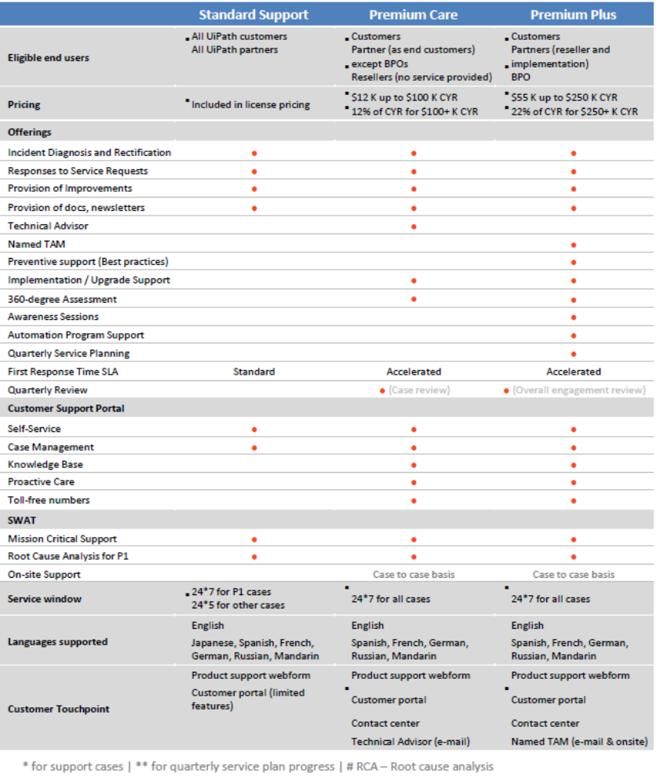

Support from UiPath vendor is available accordingly to the UiPath‘s service acquired.

Problem Management process

The RPA IT domain will adhere to the best practices considered in the “Globe - L1 Service Desk SoW - v19_Globe” documentation.

OPERATIONS

Opening Hours

Due the planned nature of these processes & activities, this side of the service is candidate to be a 5*8 service.

Request Fulfilment process

The term “Service Request” is used as a generic description for many different types of demands that are placed upon the IT organization by the user community.

Many of these are typically request for small changes that are low risk, frequently performed, low cost and based on a Service Catalogue.

Their scale and frequency, low risk nature means that they are better handled by a separate process, rather than being allowed to congest and obstruct the normal Incident and Change Management processes. This is considered a best practice in the industry.

Effective Request fulfilment has a very important role in maintaining and end user community satisfied with the services they are receiving from IT and can directly impact how well IT is perceived throughout the Business.

In order to facilitate the recording and the escalation of a Service Request from the “Service Desk – L1” to the several RPA L2 Resolver Groups, there is a key element that needs to be populated, the Service Request catalogue.

The Service Desk is the entity responsible for updating the Service Request Catalogue.

The process needed to fulfil a Service Request will vary depending upon exactly what it is requested but can usually be broken down into a set of activities that have to be performed. For each Service Request, these activities should be documented into a request model and stored in the KMS.

For service Requests that impact CIs it is recommendable to implement them through a standard Change Request. This ensure that Change Management never lose track of changes that may be introduced to CIs through the Request fulfilment process / activities.

The next chapter compiles the definitive list of entries that should be set-up into Remedy’s Service Request Catalogue.

Operations Tasks

This chapter list the services that the operations team may provide using the UiPath Orchestrator.

The following table shows the suggested mapping of the RPA services in the current service catalog. The current catalog must be updated to include the RPA services for which no equivalent was found.
Category | Service Request | Service Request mapped in current Remedy Force | Requires Service Delivery Manager  A - Approval  I - Informed
Robot
 | Add a robot VM | Infra, Server and Data Center Servies -> Request for Cloud Project Infra Srevices | A
 | Increase the robot VM's specification | Infra, Server and Data Center Servies -> Request for Cloud Project Infra Srevices | A
 | Change a robot's license | TBD | A
Orchestrator
 | Add an Orchestrator server | Infra, Server and Data Center Servies -> Request for Cloud Project Infra Srevices | A
 | Increase the Orchestrator server's specification | Infra, Server and Data Center Servies -> Request for Cloud Project Infra Srevices | A
Processes
 | Deploy a process | TBD | I
 | Delete a process | TBD | I
Triggers
 | Add a trigger | TBD | A
 | Edit a trigger | TBD | A
 | Disable a trigger | TBD | A
 | Enable a trigger | TBD | A
 | Remove a trigger | TBD | A
Queues
 | Create a queue | TBD | A
 | Delete a queue | TBD | A
Logs
 | Export logs | Data and Reports -> Request for Data Extraction  Service = Orchestrator | I
Assets
 | Create assets | TBD | I
 | Edit assets | TBD | I
 | Remove assets | TBD | I
Users
 | Add a user | Accounts and Passwords -> Request for Uesr Access  Service = Orchestrator | I
 | Edit a user | Accounts and Passwords -> Request For User Profile Management  Service = Orchestrator | I
 | Remove a user | TBD | I
Roles
 | Create a role | TBD | I
 | Modify a role of a user | TBD | I
 | Edit a custom role | TBD | I
 | Remove a custom role | TBD | I
Jobs
 | Start a job | TBD | A
 | Stop a job | TBD | A
 | Kill a job | TBD | A
 | Restart a job | TBD | A
Environments
 | Create a new environment | TBD | A
 | Add a robot(s) to an exisitng environment | TBD | A
 | Remove robot(s) from an exisitng environment | TBD | A
 | Remove an environment | TBD | A
Machines
 | Add a standard machine | TBD | A
 | Add a machine template | TBD | A
 | Delete a machine | TBD | A
 | Enable a machine | TBD | A
 | Disable a machine | TBD | A
Tenants
 | Create a tenant | TBD | A
 | Disable a tenant | TBD | A
 | Enable a tenant | TBD | A
Credential Stores
 | Create a credential store | TBD | I
 | Edit a credential store | TBD | I
 | Set a default credential store | TBD | I
 | Delete a credential store | TBD | I
Licenses
 | Renew/update a license | TBD | A
 | Deactivate a license | TBD | A
 | Allocate a license | TBD | A
 | Remove a tenant license | TBD | A
 | Remove a host license | TBD | A

Roles & Job Descriptions

RPA Service Delivery Manager (SDM)

Accountabilities for the Role:
- Must fulfil the Service’s SLAs
- Must play a key role in the Service Delivery process improvement reviews to identify improvement opportunities where the Service should drive benefits and efficiencies for the business.
- Must ensure that reporting metrics are put in place to measure the performance of the Service.
- Must have accountability in the transitioning of high performing service support functions to ensure that the RPA solutions are performant and deliver in line with expected service levels.
- Build relationships and work closely with stakeholders across ISG and the Business to be well positioned to identify future opportunities for Service process improvement.
- Supporting existing project management processes and implementing change requirements as part of a structured change control process.
Competencies of the Role:
- Leadership & Change.
- Operational Excellence.
- Innovative and creative approach to problem solving
- Accountability & Decision Making.
- Communication & Influencing. Excellent communication skills, both verbal and written, with the ability to produce easily understood documentation
- Embraces change, with solid Service Management skills.

Technical Competences for the Role:
- Degree or equivalent in Computer Science or related field
- More than 3 years’ experience working as Service Delivery Manager (SDM)
- More than 1 year experience working within the RPA domain
- ITIL® Foundations and ITIL® Service Operations certified
- Demonstrable knowledge of the UIPath platform
- Experience presenting to Senior management
- Highly recommendable but not essential: ITIL® Continual Service Improvement certification

Support Analyst
Put here capabilities and requirements

Service Level Agreement (SLAs) Management process

How to define Impact?

The introduction of digital technologies, such is RPA and the ones associated to social media is starting to challenge the currents paradigms in regards how we should define Impact and Urgency.
Impact should also be a measure of the actual or potential negative effects of an Incident on Globe’s customers, service or brand, as addressed in the following table:

Numbers of affected Customers | Affecting this many customers | Give this rating
More than 25% of customers unable to use or access a service | Lots | 1
Up to 25% of customers unable to use or access a service or multiple customer care sites affected | Some | 2
Just single report of impact to service | Few | 3

But, instead of purely defining Impact based on a number of affected customers due a loss of availability or degradation of a Service, we are starting to consider other point of views such as the level of media exposure of an Incident:
Level of potential media exposure of the Incident | Scale of the Business Impact | Give this rating
Exposure of the brand or his top managment (CEO, etc.) in the TV news and with Watchdog type journalism. | High | 1
Social media activity associated to VIP customers, per example in local media, local social media groups. | Medium | 2
Social media posts from individual customers. | Low | 3

Finally, we use both ratings to find the overall impact:

Use this rating to calculate the final Impact
Customer | Business | Final Impact
1 | 1 | 1 - Extensive/Widespread
1 | 2 | 2 - Significant/Large
2 | 1 | 2 - Significant/Large
2 | 2 | 3 - Moderate / Limited
1 | 3 | 3 - Moderate / Limited
3 | 1 | 3 - Moderate / Limited
2 | 3 | 4 - Minor / Localized
3 | 2 | 4 - Minor / Localized
3 | 3 | 4 - Minor / Localized

How to define Urgency?

Having in mind that Urgency is a measure of the actual or risk of degradation caused by an Incident to Globe’s customer, service or brand, the Urgency may be defined based on the following tables:
If the Incident is affecting these Configuration Items | We say it is affecting this kind of services | Give this rating
Globe shop, VIP, Recharge facility | Tier 1 | 1
Globe One app, Customer care systems | Tier 2 | 2
Billing applications | Tier 3 | 3

And

The type of disruption | We say that the level of degradation is | Give this rating
A complete service has been loss with no other option for customers | Total | 1
A reduction in the ability to use a service or a range of services | Loss of resilience | 2
A reduction in the quality of a service or in the ability to use the service | Partial/None | 3

Finally, we use both ratings to find the overall impact:

Use this rating to calculate the final Urgency
Customer | Business | Final Urgency
1 | 1 | 1 - Critical
1 | 2 | 2 - High
2 | 1 | 2 - High
2 | 2 | 3 - Medium
1 | 3 | 3 - Medium
3 | 1 | 3 - Medium
2 | 3 | 4 - Low
3 | 2 | 4 - Low
3 | 3 | 4 - Low

How to determine the Criticality?

The level of Criticality of an Incident will be determined following the subsequent matrix and will be based on the Impact and the Urgency of the Incident:

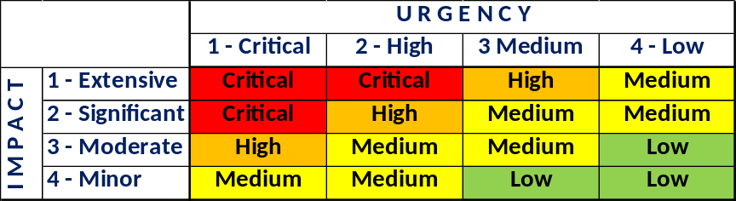

L2 ISG RPA Support service

Follows the SLAs considered for this L2 ISG RPA Support service:

      - Incidents
- Response time: it is the period of time that the provider has to start the analysis of the Incident
- Resolution Time: it is the period of time that the provider has to take any workaround of definitive action to restore the service. It does not have to be the definitive solution.
Criticality |  | Response Time | Resolution Time
1 | Critical | 15 m | 2 hours
2 | High | 15 m | 4 hours
3 | Medium | 15 m | 18 hours
4 | Low | 15 m | 40 hours

Response Time and Resolution Time SLAs need to be measured separately.

90% of all Incidents must fulfil the SLAs measured on a yearly basis.

      - Service Requests
Follows the SLAs considered for this L2 ISG RPA Request fulfilment process:

Criticality |  | Resolution Time (8*5 working hours)
1 | Critical | 4 hours
2 | High | 9 hours
3 | Medium | 18 hours
4 | Low | 40 hours

90% of all Service Request must fulfill the SLA measured on a yearly basis.

L2 Support Service reporting

There can be defined a set of reports to be produced, by the Service team to be provided to Globe’s Service Manager for quality control of the operation.

Example of reports that could be provided are shown below:
REPORT | PURPOSE | CONTENT
Operational Report | To monitor all requests, to ensure their resolution and check their closing, all according to the agreed SLA. | - Statistics of open and resolved Incidents  - Details of processed Service Requests, including priority level, type of request, status, and diagnosis  - Trending of received Incidents  - Weekly, monthly, quarterly and annual reports for different kinds of purposes to monitor overall service quality.
SLA Report | To analyze the fulfillment of the SLAs during the indicated period | - Demand baselining (baseline vs. consumed)  - Issues / recommendations / risks  - Other highlights / considerations
Overall Service Evaluation Report | To report the degree of fulfillment of the commitment on continual improvement of the service | - Statistics on SLAs  - Plans of action for improvement

Continuous Improvement
The documents will have the same people assigned to review and sign-off the documents. In case there are changes in the approvers, the new person assigned to review and update the document must be listed in the version control table of the document.
All the changes made in the guidelines documents with proper sign off should clearly be followed.

APPENDIX

Preconditions on Running the Robot/s

Before the bot can automatically run, we have to ensure the following:
- Package is uploaded in the Orchestrator.
- Robot is connected and available.
- Schedule set in orchestrator is correct.
- Assets (Credentials, URLs) are updated in the orchestrator.

Package - ensuring that there is a package uploaded
Steps:
- Connect to the local host of the orchestrator server.
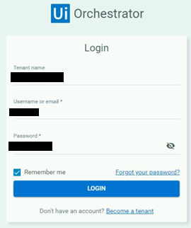

- In the left sidebar, go to Processes, and make sure that there is a package uploaded.
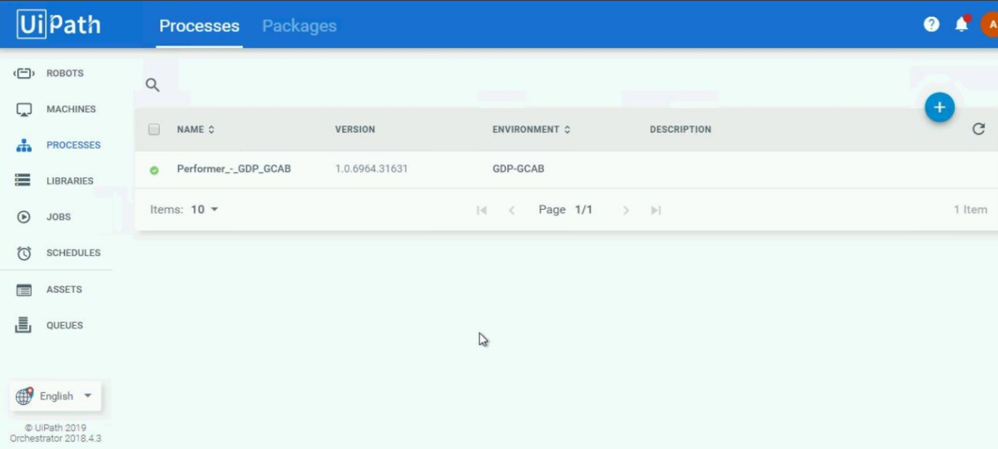

Robot – ensuring that the robot is available / busy
Steps:
- In the left sidebar, Go to Robots, and make sure that the status of the Robot is Available. Once the job is triggered via the schedule (see Section 2.3 for the Scheduling), the status of the robot will be Busy.
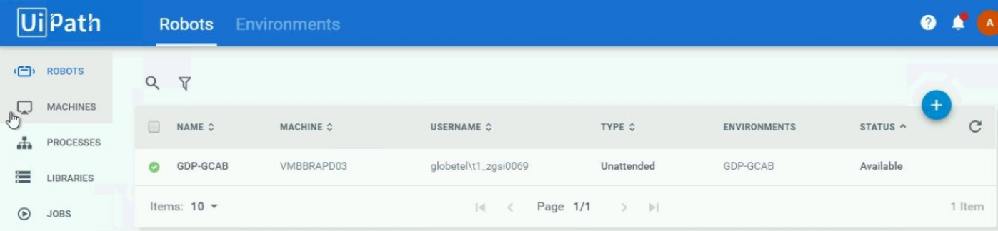

- The possible statuses of the robots are listed below:
  - Available - the Robot is not running a process and is free to be used; or waiting for the scheduled activity.
  - Busy - the Robot is running a process;
  - Unresponsive - the Robot and Orchestrator have not communicated in the last two minutes - the default scenario. This value can be configured in the web.config file.
  - Disconnected - the UiPath Robot service is not running.

Schedule – ensuring that the preferred schedule running time of the Robot is configured in the Orchestrator
Steps:
- In the left sidebar, go to Schedules, and make sure that the details of the schedule is correct.
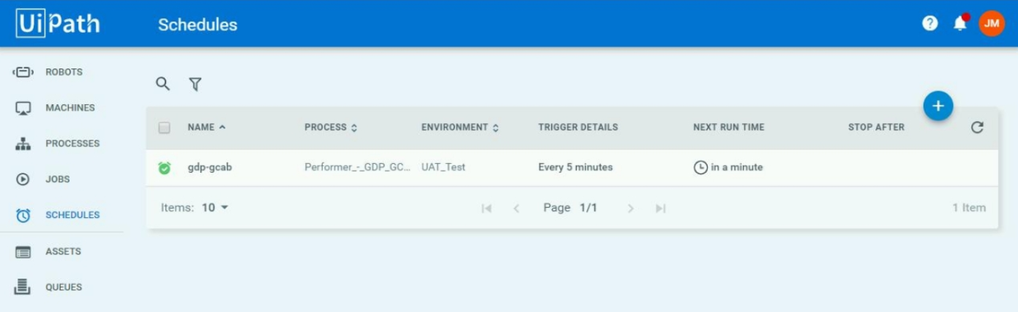

Assets – ensuring that credentials, URLs, links are updated in the Orchestrator
Steps:
- In the left sidebar, go to Assets, and make sure that the credentials and URLs are correct. The credentials and links value can be manually updated in the orchestrator.
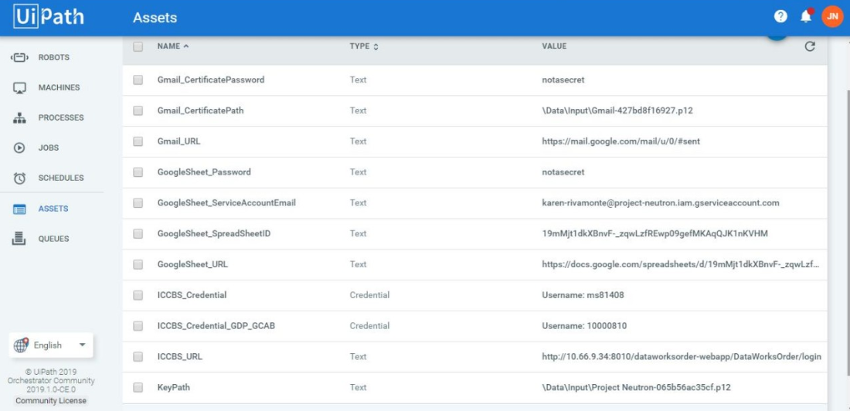
- For updating the information in the assets, click the Edit button in the information we want to update. A new window will pop-up where we can set new values.
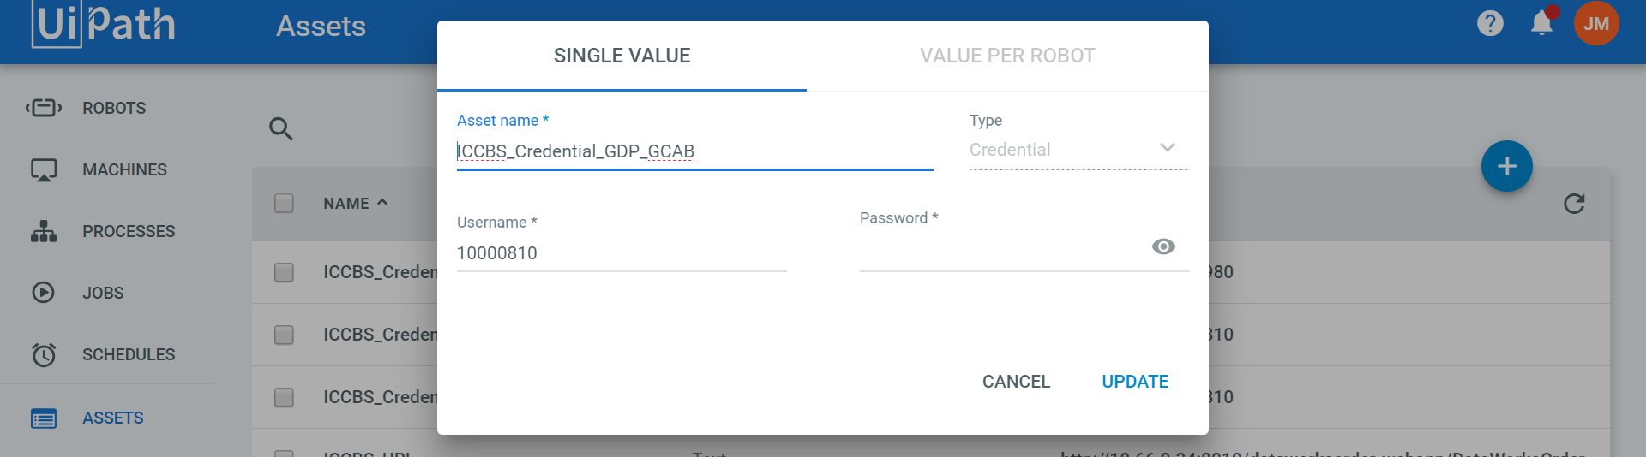

Manually Running the Robots
In any case the robot have to run out of the predefined schedule set in orchestrator (see Schedule Section for the Scheduling), steps in manually running the robot are stated below:
Steps:
- In the desktop taskbar, click the UiPath icon, and click the Start button, in order to manually run the bot.
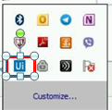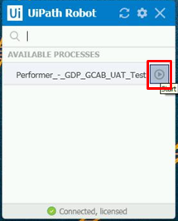

REFERENCES
https://docs.uipath.com/orchestrator/docs/introduction

